**Call for Proposals**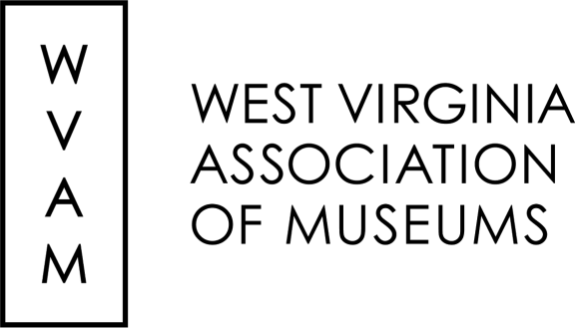

***Museums as a***

***Critical Community Asset***

**2025 Annual Meeting and Conference**

**Huntington, WV**

**April 3-5, 2025**

The West Virginia Association of Museums’ annual meeting and conference will be held April 3-5, 2025, at the Doubletree by Hilton in Huntington, West Virginia. The theme of WVAM’s 2025 conference is “Museums as a Critical Community Asset.”

WVAM is now accepting proposals for papers, presentations, workshops, and poster sessions addressing our theme of “Museums as a Critical Community Asset.” Potential topics include (but are not limited to):

-How museums represent the local, state, and regional history of West Virginia

-What museums provide to their communities (i.e. community spaces, preserving identity and culture, educational opportunities,heritage tourism)

-How museums can connect to their communities (i.e. gaining volunteers, fundraising, outreach)

-How museums and cultural institutions can promote a vibrant local, state, and regional history

As always, WVAM is also accepting proposals for sessions that focus on interpretation, communication, diversity and inclusion, marketing/PR, fundraising, educational resources, constructing exhibits, and other public history topics. Please email us at museumsofwv@gmail.com if you have questions.

In addition, WVAM is now accepting proposals for poster presentations from students, AmeriCorps members, or institutions wanting to share research or projects. These posters can address our conference theme, but do not have to. Poster presentations can present any research or projects related to public history, museums, and similar institutions.

The deadline for submission of proposals is February 15, 2025.

The mission of the West Virginia Association of Museums is to serve, educate, advocate for, and enhance communications within the museum community. By listening to its members, serving their interests, and keeping members informed of current national standards and activities, WVAM works to benefit institutions, professionals, volunteers, and others interested in the museums of the Mountain State.

**WVAM 2025**

***Museums as a Critical Community Asset***

**Proposal Submission Form**

**Submission Deadline: February 15, 2025**

**Title of Session/Panel/Workshop:**

**Description: (Please include goals, session abstract, and relevance to WVAM’s purpose or conference theme. 150 words maximum. Use back or attach sheets if necessary.)**

**Summary: (Please include a summary on the back of this sheet or attach sheets if necessary.)**

**Session format and length:**

**__45 minute paper/session __ 90 minute paper/session**

**__45 minute panel discussion __ 90 minute panel discussion**

**__ Other (please describe) ___________________________________________________________________**

**Is session sponsored by a Professional Interest Group? Which one? ______________________________**

**Media Needs:**

**__Laptop __Projector**

**__Other (please describe) ___________________________________________________________________**

**Presenter/Session Leader:**

**Name: ___________________________________ Affiliation, if any: _____________________________**

**Address: ___________________________________________**

**___________________________________________**

**Telephone: __________________________________________**

**Email: ___________________________________________________________________________________**

**Additional Participants: (please include name, affiliation, and contact information, as well as session contribution for each presenter. Attach additional sheets as needed)**

**______________________________________________________________________________________________________________________________________________________________________________________________________________________________________________________________________________**

**Important Note: WVAM does not pay honoraria or travel expenses.**

**Send to: WVAM, PO Box 4589, Morgantown, WV 26504**

**museumsofwv@gmail.com phone: 304.813.8569**